**Algorithms:**

1. Main Screen :

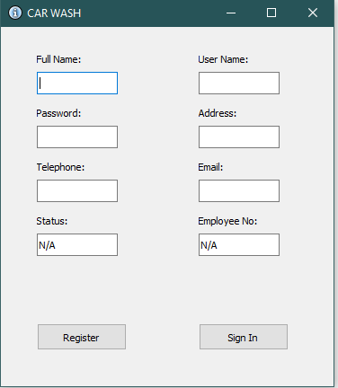

Enter all necessary info.

If simple user, leave status and employee no as empty.

Else if employee or manager, write Employee or Manager in status as well as 01 or 02 in Employee no.

Click register to register the specified user type.

Or, press Sign in to move onto sign in screen.

1. Sign in Screen :

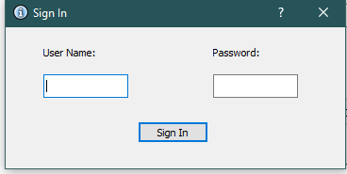

Enter username and password and press signin button.

If correct credentials, takes to the Main Page, depending on the type of user.

If incorrect info, the program closes.

1. User Main :

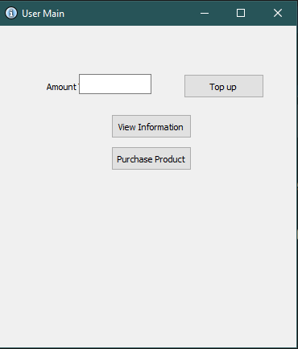

This screen appears if the user logs into the system as a regular user.

User can write amount to be added to his washcard.

User can view his profile info.

User can click purchase product button to see list of products that he can buy.

1. View info:

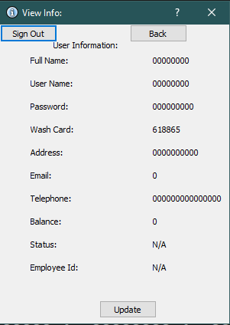

Views currently logged in user’s info.

Click sign out to sign out of the system and move to first register screen.

Click back button to go back to User Main screen.

Click update to open user information update screen, where user can update current information.

1. Purchase products:

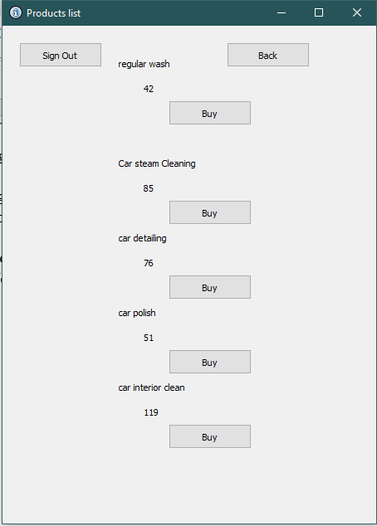

Displays all the available products.

Applies discount on the prices of each product, based on user type: e-g:

Regular user get 15 % discount, employees get 30 %, while managers get 50 % discount.

Click buy button to buy any product.

After clicking buy, it checks if user has enough amount in their washcard to buy product or not.

If enough amount is present, then this amount is deducted from their washcard and product is bought, else the message that not enough amount in washcard is printed.

1. Top up:



User enters the amount he wants to add to their washcard in the amount textbox and presses the Top up button.

Program adds the amount to their already existing amount present in the record.txt file.

1. Employee Main Screen:

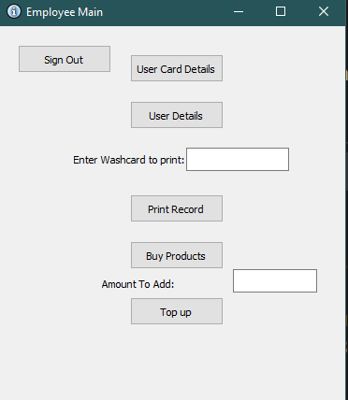

Screen displayed after an Employee logs into the system.

Gives option to view details of user’s cards, view user’s details, display information for a specific washcard number,

Print records, buying products and adding amount to his washcard.

1. User Card Details:

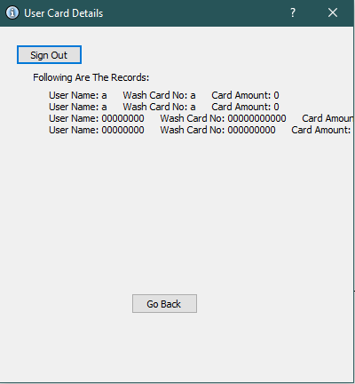

Employee can view the list of all washcards in the system.

It display information such as username , washcard number, as well as the amount present on the washcard.

Employee can click on signout to sign out of his account or click go back to go back to Employee Main screen.

1. User Details:

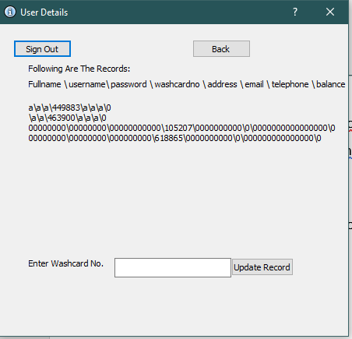

Employee clicks user details button on employee main screen to get to this screen.   
  
He can then view all the users saved in the record.txt file.

He can also enter the washcard number of any specific user to update any detail of that user.

1. Print info:

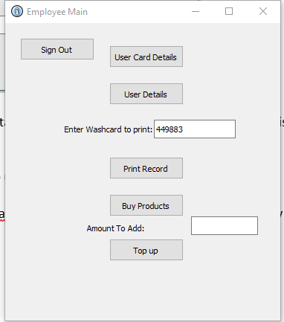

Employee has to enter the washcard number of any user whose information he wishes to see, and then click print record.

If no washcard number is provided a message appears in the text label that a washcard number should be provided :

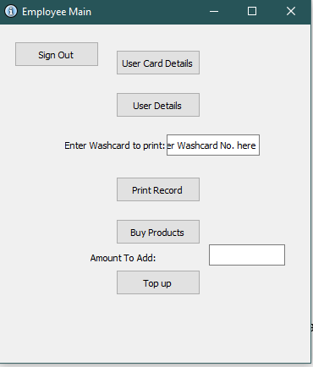

After providing washcard number, employee clicks print record to view the details of the specific user.

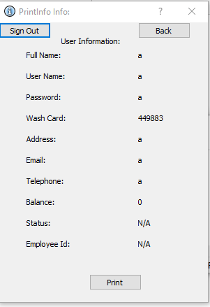

This now displays the information for the user whose washcard number was provided on the previous screen.

Click back to go to previous screen.

1. Employee buy products:

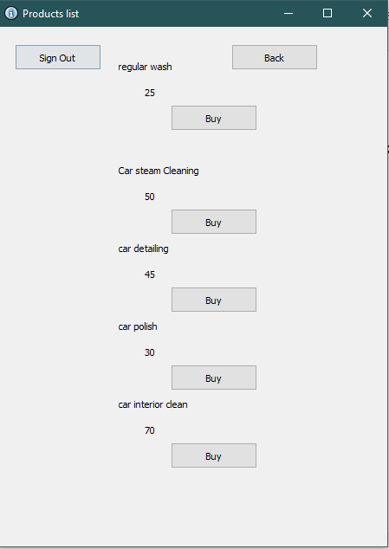

Same as user buy products, but, the price of each product is discounted by 30 %.

Same as user, if the employee clicks buy button, it first checks if employee has enough amount in washcard, if yes then product is bought and if no then message printed that not enough amount.